# First Fit

#include <iostream>

using namespace std;

int main() {

int memBlocks[] = {300, 600, 350, 200, 750, 125};

int numBlocks = 6;

int processes[] = {115, 500, 358, 200, 375};

int numProcesses = 5;

int allocation[numProcesses];

int i = 0;

while (i < numProcesses) {

allocation[i] = -1;

int j = 0;

while (j < numBlocks) {

if (memBlocks[j] >= processes[i]) {

allocation[i] = j;

memBlocks[j] -= processes[i];

break;

}

j++;

}

i++;

}

cout << "Process No.\tProcess Size\tPartition No.\n";

i = 0;

while (i < numProcesses) {

cout << i+1 << "\t\t" << processes[i] << "\t\t";

if (allocation[i] != -1) {

cout << allocation[i]+1;

} else {

cout << "Not Allocated";

}

cout << endl;

i++;

}

return 0;

}

out put

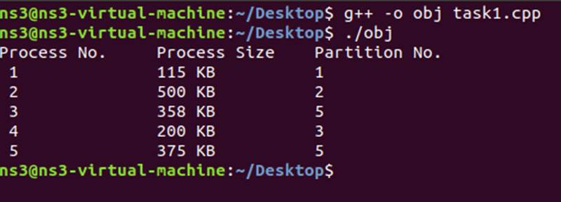

BEST FIT  
  
#include <iostream>

using namespace std;

int main() {

int memory_blocks[] = {300, 600, 350, 200, 750, 125};

int num_blocks = 6;

int processes[] = {115, 500, 358, 200, 375};

int num_processes = 5;

int allocation[num_processes];

int i = 0;

while (i < num_processes) {

allocation[i] = -1;

int best_index = -1;

int j = 0;

while (j < num_blocks) {

if (memory_blocks[j] >= processes[i]) {

if (best_index == -1) {

best_index = j;

} else {

if (memory_blocks[j] < memory_blocks[best_index]) {

best_index = j;

}

}

}

j++;

}

if (best_index != -1) {

allocation[i] = best_index;

memory_blocks[best_index] -= processes[i];

}

i++;

}

cout << "Process No.\tProcess Size\tPartition No.\n";

i = 0;

while (i < num_processes) {

cout << i+1 << "\t\t" << processes[i] << "\t\t";

if (allocation[i] != -1) {

cout << allocation[i]+1;

} else {

cout << "Not Allocated";

}

cout << endl;

i++;

}

return 0;

}

# OUT PUT

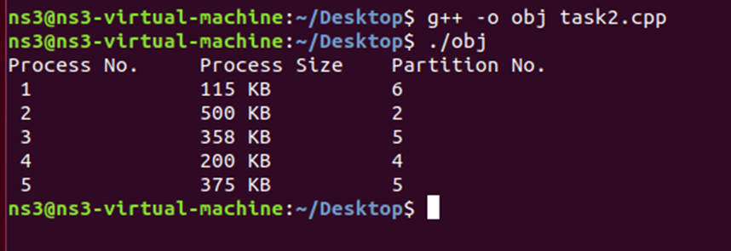

# WORST FIT

#include <iostream>

using namespace std;

int main() {

int memory_blocks[] = {300, 600, 350, 200, 750, 125};

int num_blocks = 6;

int processes[] = {115, 500, 358, 200, 375};

int num_processes = 5;

int allocation[num_processes];

int i = 0;

while (i < num_processes) {

allocation[i] = -1;

int worst_index = -1;

int j = 0;

while (j < num_blocks) {

if (memory_blocks[j] >= processes[i]) {

if (worst_index == -1 || memory_blocks[j] > memory_blocks[worst_index])

worst_index = j;

}

j++;

}

if (worst_index != -1) {

allocation[i] = worst_index;

memory_blocks[worst_index] -= processes[i];

}

i++;

}

cout << "Process No.\tProcess Size\tPartition No.\n";

int k = 0;

while (k < num_processes) {

cout << k+1 << "\t\t" << processes[k] << "\t\t";

if (allocation[k] != -1)

cout << allocation[k]+1;

else

cout << "Not Allocated";

cout << endl;

k++;

}

return 0;

}

# OUTPUT

